**FRETX MAIN UIS**

General requirement:

* Uniform color theme
* Text size/font for different levels of display
* Simple, modern design
* Rearrange layout of menu screen (remove text “Device not connected”, change to more standard Bluetooth connection button, redesign to give maximum screen to 4 main menu)

Play menu:

* Better list layout for video

Learn menu:

* Better list layout for exercise list
* 2 modes for exercise button, enabled and disabled
* Better layout for note practice
* Better layout for score screen

Chord menu:

* Sliding layout + button for chord selection. New design should come with 2 sliding bars, 1 for chords (C, D, A…), and 1 for chord types (major, minor, 7…)

Ex:

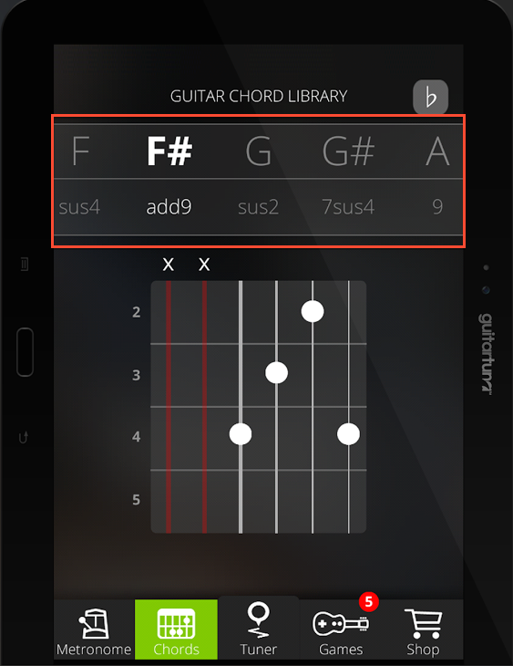

Tuner menu:

* Redesign of tuner display

Ex:

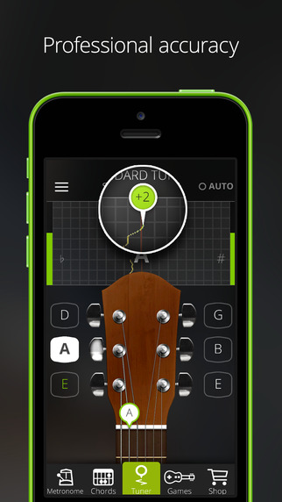 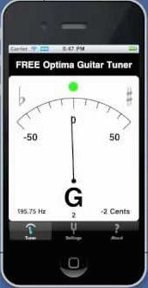

# STARTING SCREENS

### App starting screen

# 

### Facebook log-in

### 

### Introduction video

### 

# MAIN MENU

Side navigation

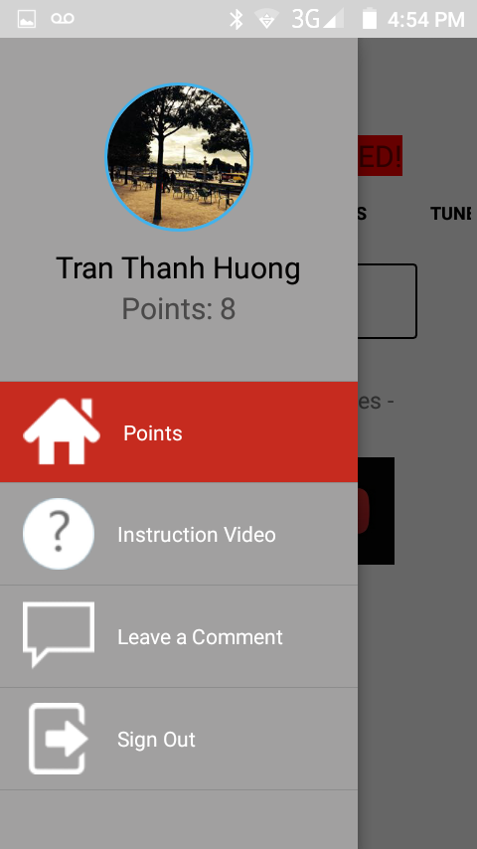

## Play Menu

List Play Youtube video

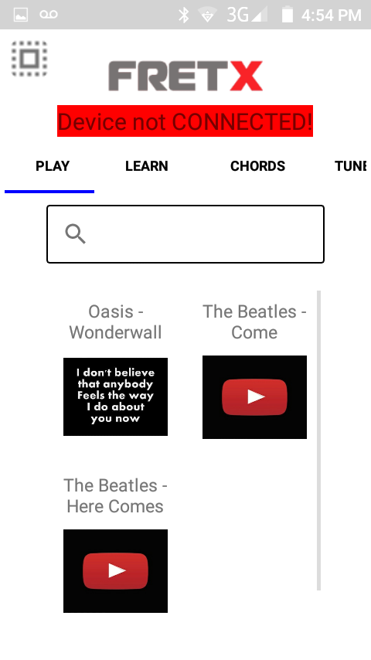 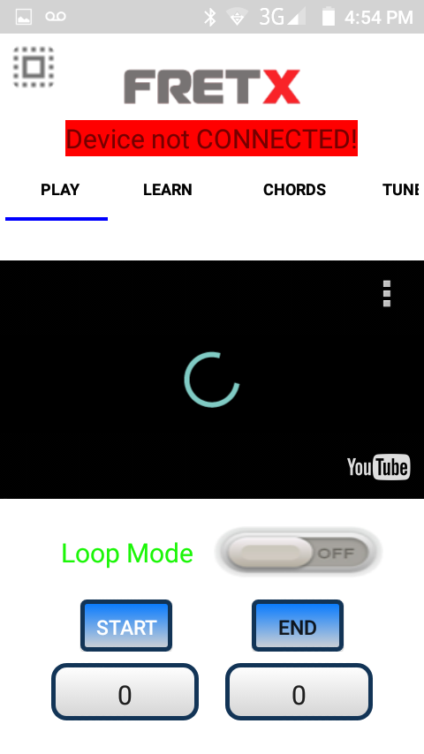

## Learn Menu

List

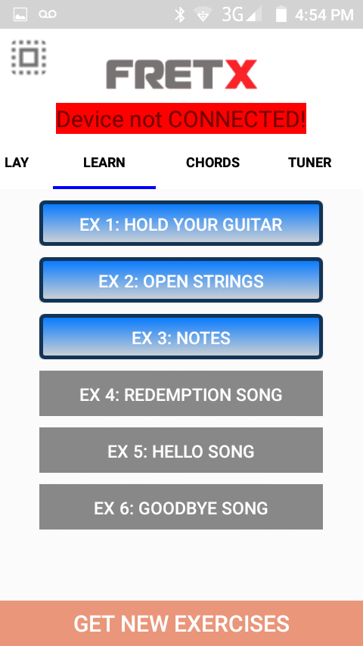

Play instruction video

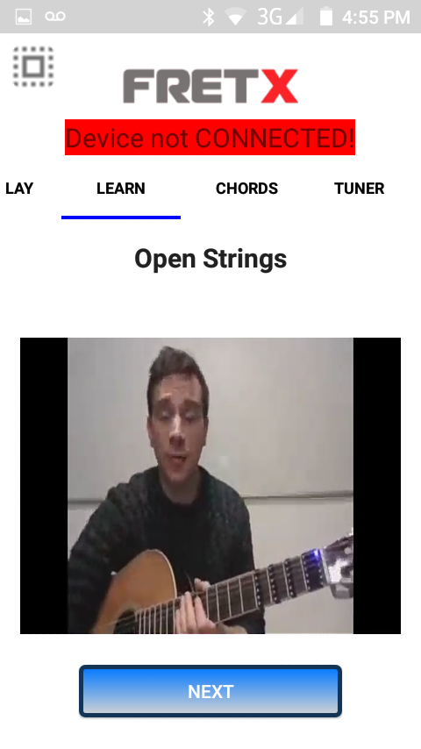

Note practice

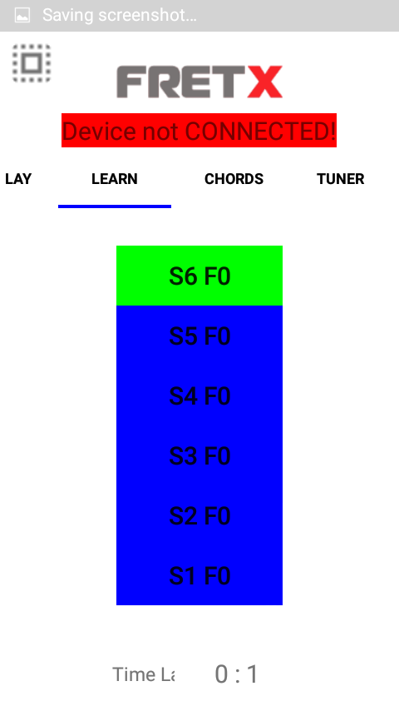

Score screen

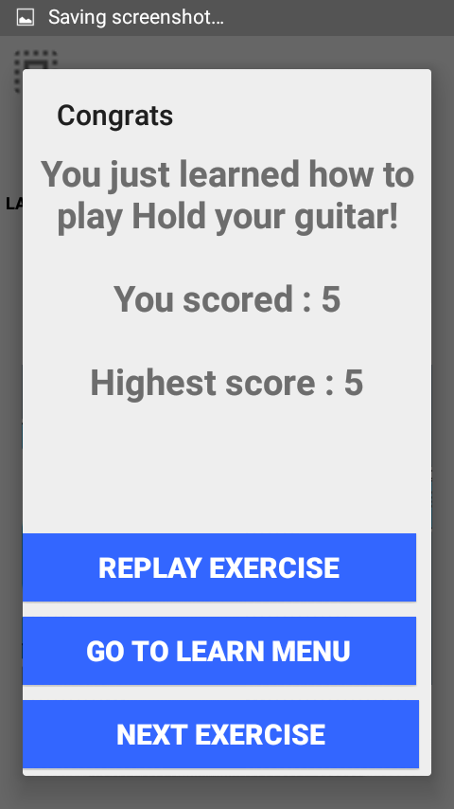

## Chord Menu

Chord selector slide bar

Chord image display

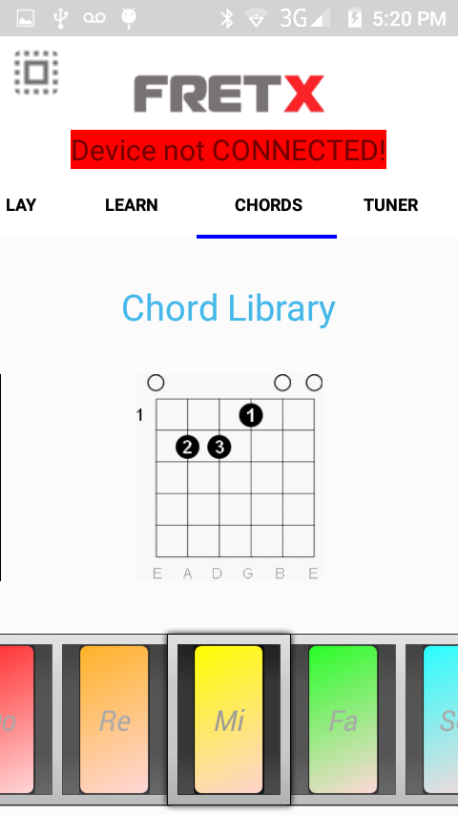

## Tuner Menu

